MA 323 Lab-01 report
Pavan Kumar A
210123043

Q1)

Sequence for a=6, b=0, m=11:
Sequence  /  Seeds | 1st | 2nd | 3rd | 4th | 5th | 6th | 7th | 8th | 9th | 10th
0 | 0 | 0 | 0 | 0 | 0 | 0 | 0 | 0 | 0 | 0
1 | 1 | 6 | 3 | 7 | 9 | 10 | 5 | 8 | 4 | 2
2 | 2 | 1 | 6 | 3 | 7 | 9 | 10 | 5 | 8 | 4
3 | 3 | 7 | 9 | 10 | 5 | 8 | 4 | 2 | 1 | 6
4 | 4 | 2 | 1 | 6 | 3 | 7 | 9 | 10 | 5 | 8
5 | 5 | 8 | 4 | 2 | 1 | 6 | 3 | 7 | 9 | 10
6 | 6 | 3 | 7 | 9 | 10 | 5 | 8 | 4 | 2 | 1
7 | 7 | 9 | 10 | 5 | 8 | 4 | 2 | 1 | 6 | 3
8 | 8 | 4 | 2 | 1 | 6 | 3 | 7 | 9 | 10 | 5
9 | 9 | 10 | 5 | 8 | 4 | 2 | 1 | 6 | 3 | 7
10 | 10 | 5 | 8 | 4 | 2 | 1 | 6 | 3 | 7 | 9

Sequence for a=3, b=0, m=11:
Sequence  /  Seeds | 1st | 2nd | 3rd | 4th | 5th
0 | 0 | 0 | 0 | 0 | 0
1 | 1 | 6 | 3 | 7 | 9
2 | 2 | 1 | 6 | 3 | 7
3 | 3 | 7 | 9 | 10 | 5
4 | 4 | 2 | 1 | 6 | 3
5 | 5 | 8 | 4 | 2 | 1
6 | 6 | 3 | 7 | 9 | 10
7 | 7 | 9 | 10 | 5 | 8
8 | 8 | 4 | 2 | 1 | 6
9 | 9 | 10 | 5 | 8 | 4
10 | 10 | 5 | 8 | 4 | 2
- In case 1 where a=6, 10 values appear before repeating, and in case 2 where a=3,
5 values appear before repeating.
- Best Choice: the full period of m-1(=10 in this case) happens when a=6 so it is clearly the better choice over a=3 as its period is only 5.
Therefore a=6 is the better choice for random numbers.

Output:

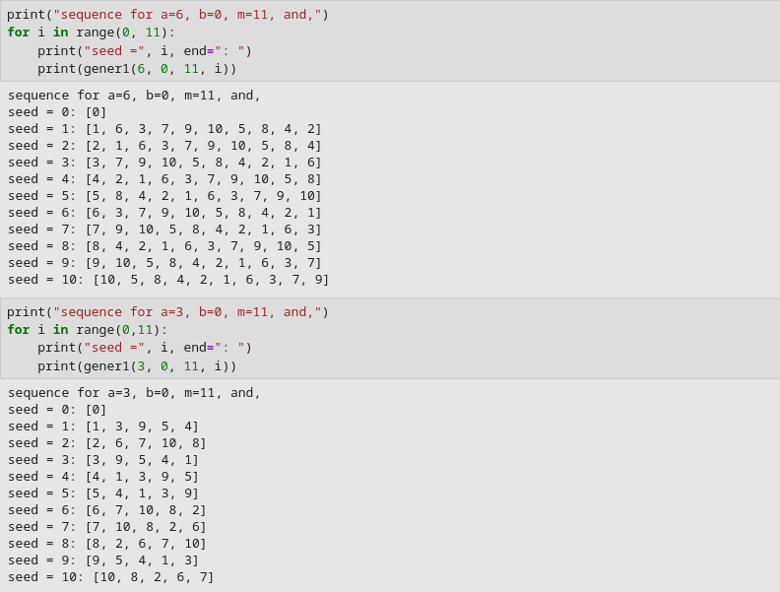

__________________________________________________________________________
Q2)

a=1597, b=1, m=244944:

Seeds  /  Ranges | x₀=1 | x₀=3 | x₀=4 | x₀=6 | x₀=7 | x₀=9
0-0.05 | 496 | 498 | 450 | 474 | 555 | 460
0.05-0.1 | 455 | 491 | 501 | 524 | 509 | 570
0.1-0.15 | 544 | 572 | 468 | 534 | 486 | 510
0.15-0.2 | 516 | 503 | 586 | 508 | 495 | 466
0.2-0.25 | 476 | 459 | 502 | 463 | 455 | 501
0.25-0.3 | 496 | 497 | 465 | 494 | 549 | 481
0.3-0.35 | 451 | 485 | 490 | 526 | 507 | 565
0.35-0.4 | 554 | 567 | 488 | 535 | 476 | 500
0.4-0.45 | 518 | 499 | 558 | 497 | 500 | 477
0.45-0.5 | 477 | 460 | 505 | 481 | 455 | 499
0.5-0.55 | 494 | 501 | 448 | 467 | 562 | 455
0.55-0.6 | 462 | 465 | 503 | 524 | 526 | 568
0.6-0.65 | 554 | 548 | 478 | 535 | 468 | 512
0.65-0.7 | 505 | 493 | 557 | 491 | 512 | 466
0.7-0.75 | 488 | 462 | 501 | 486 | 452 | 509
0.75-0.8 | 485 | 485 | 448 | 467 | 562 | 445
0.8-0.85 | 468 | 477 | 506 | 496 | 503 | 543
0.85-0.9 | 554 | 565 | 468 | 526 | 470 | 510
0.9-0.95 | 511 | 517 | 575 | 505 | 497 | 456
0.95-1 | 496 | 456 | 493 | 467 | 471 | 507

a=51947, b=1, m=244944:

Seeds  /  Ranges | x₀=1 | x₀=3 | x₀=4 | x₀=6 | x₀=7 | x₀=9
0-0.05 | 195 | 194 | 195 | 195 | 193 | 195
0.05-0.1 | 194 | 193 | 194 | 194 | 197 | 195
0.1-0.15 | 195 | 196 | 194 | 194 | 192 | 192
0.15-0.2 | 193 | 193 | 195 | 194 | 197 | 195
0.2-0.25 | 195 | 196 | 194 | 195 | 193 | 195
0.25-0.3 | 195 | 194 | 195 | 195 | 193 | 195
0.3-0.35 | 194 | 193 | 194 | 194 | 197 | 195
0.35-0.4 | 194 | 196 | 194 | 194 | 192 | 192
0.4-0.45 | 194 | 193 | 195 | 194 | 197 | 195
0.45-0.5 | 195 | 196 | 194 | 195 | 193 | 195
0.5-0.55 | 195 | 194 | 195 | 195 | 193 | 195
0.55-0.6 | 194 | 193 | 194 | 194 | 197 | 195
0.6-0.65 | 195 | 196 | 194 | 194 | 192 | 192
0.65-0.7 | 193 | 193 | 195 | 194 | 197 | 195
0.7-0.75 | 195 | 196 | 194 | 195 | 193 | 195
0.75-0.8 | 195 | 194 | 195 | 195 | 193 | 195
0.8-0.85 | 194 | 193 | 194 | 194 | 197 | 195
0.85-0.9 | 194 | 196 | 194 | 194 | 192 | 192
0.9-0.95 | 194 | 193 | 195 | 194 | 197 | 195
0.95-1 | 195 | 196 | 194 | 195 | 193 | 195

Bar Diagram for a=1597, b=1, m=244944, x₀=1:

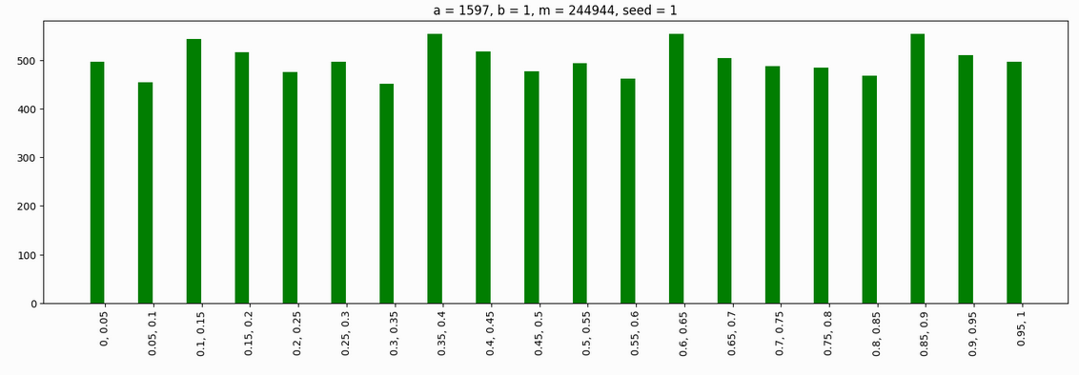

Bar Diagram for a=51749, b=1, m=244944, x₀=1:

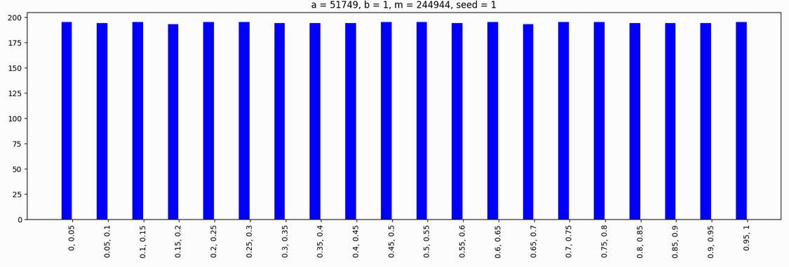
Bar Diagram for a=1597, b=1, m=244944, x₀=3:

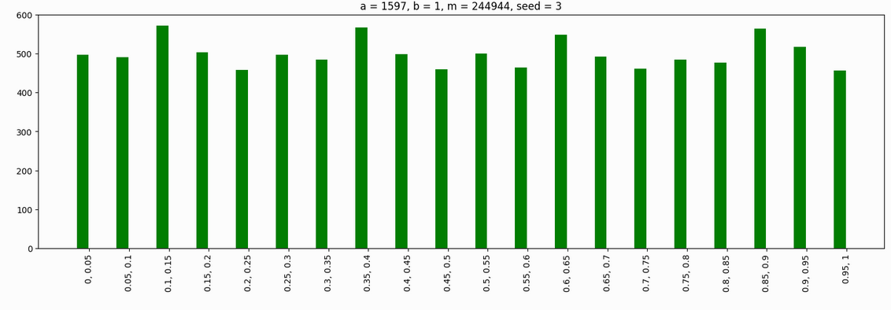

Bar Diagram for a=51749, b=1, m=244944, x₀=3:

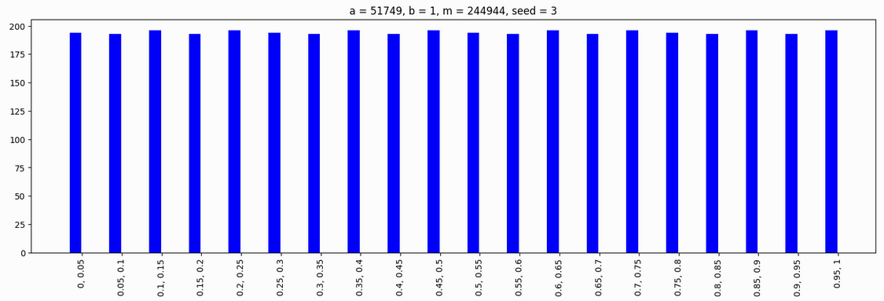

Bar Diagram for a=1597, b=1, m=244944, x₀=4:

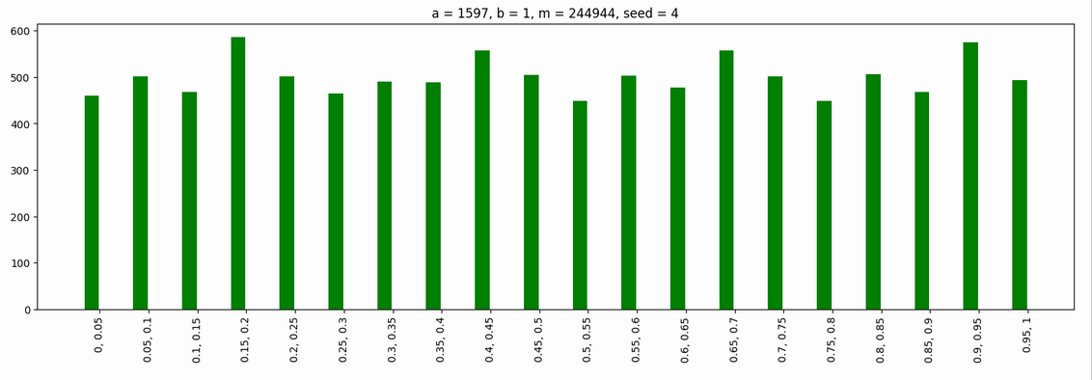

Bar Diagram for a=51749, b=1, m=244944, x₀=4:

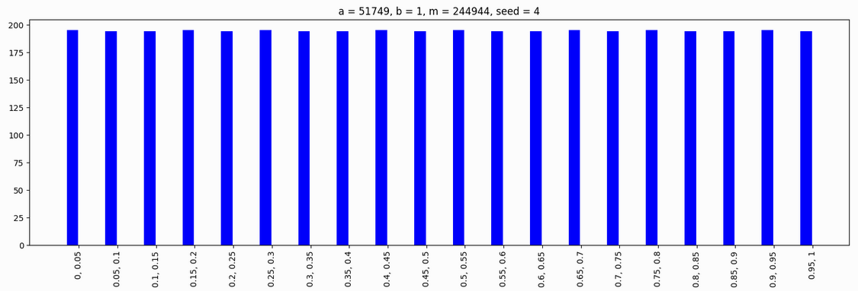

Bar Diagram for a=1597, b=1, m=244944, x₀=6:

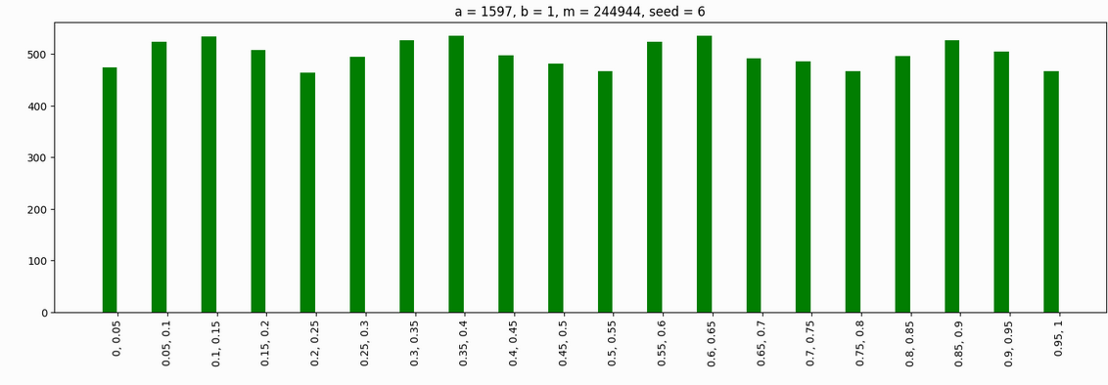
Bar Diagram for a=51749, b=1, m=244944, x₀=6:

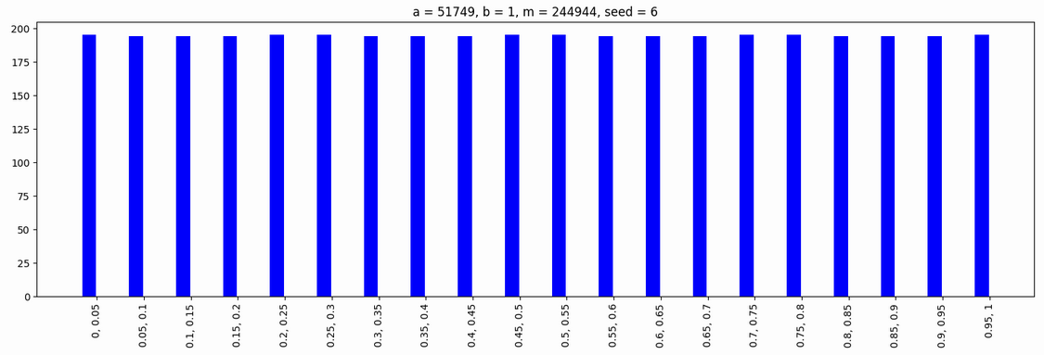
Bar Diagram for a=1597, b=1, m=244944, x₀=7:

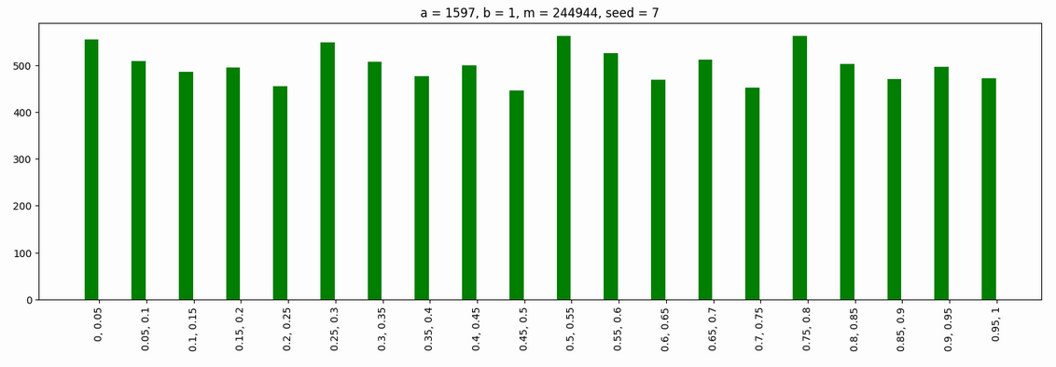

Bar Diagram for a=51749, b=1, m=244944, x₀=7:

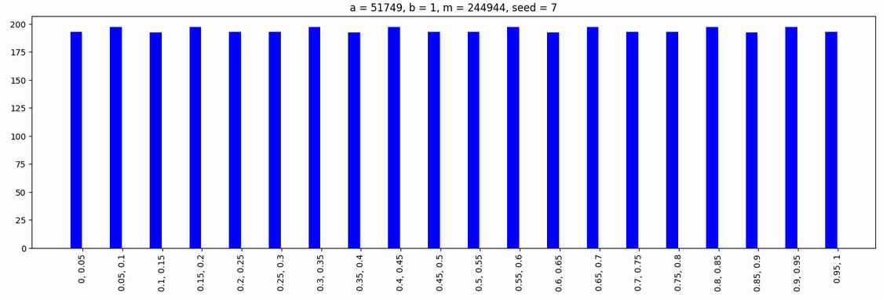
Bar Diagram for a=1597, b=1, m=244944, x₀=9:

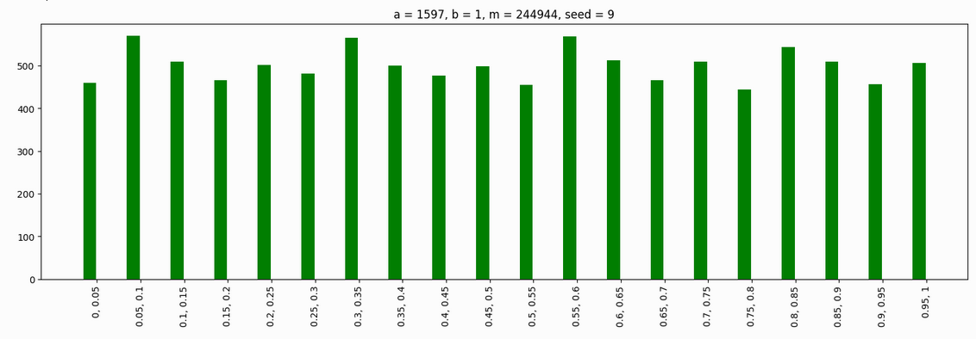
Bar Diagram for a=51749, b=1, m=244944, x₀=9:

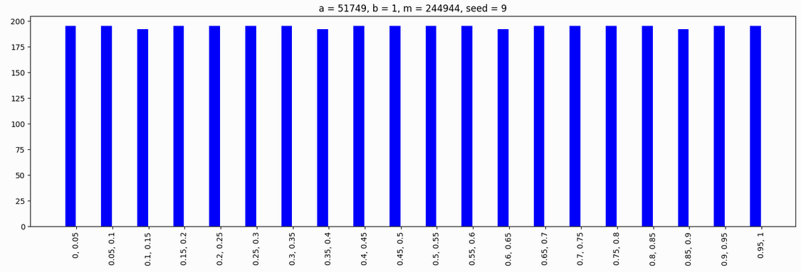

Observations:
- For different values of seed(x₀), the frequencies are almost same and so the bar graphs are also identical.
- When a=1597, the sequence has full period of m-1, while when a=51749 the sequence does not achieve its full period.

__________________________________________________________________________

Q3)

Scatter plot of (u_{i-1}, u_{i}) when a=1229, b=1, m=2048, and seed(x₀)=1:

